My Music App - Django Basics Exam Prep I
More exam preps at SoftUni Judge System
The app allows a user to browse different albums, including the author, genre, and price. The user can create a catalog of albums. Album creators can also edit or delete their posts at any time.

Skeleton
All essential HTML pages, images, and CSS resources for the project have been provided to you.

Structure
Establish a well-organized project structure by initiating at least two Django apps and configuring the corresponding URLs.
You have the flexibility to utilize both Function-Based Views and Class-Based Views as needed.
Adhere to best practices and uphold the separation of concerns principle for a robust and maintainable codebase.

Database
You will need to create two models:
- Profile
  - Username
    - Character field, required.
    - It should have at least 2 characters and maximum - 15 characters.
    - The username can consist only of letters, numbers, and underscore ("_"). Otherwise, raise a ValidationError with the message: "Ensure this value contains only letters, numbers, and underscore."
  - Email
    - Email field, required.
  - Age
    - Integer field, optional.
    - The age cannot be below 0.
- Album
  - Album Name
    - Character field, required.
    - All album names must be unique.
    - It should consist of a maximum of 30 characters.
  - Artist
    - Character field, required.
    - It should consist of a maximum of 30 characters.
  - Genre
    - Character field, required.
    - It should consist of a maximum of 30 characters.
    - The choices are "Pop Music", "Jazz Music", "R&B Music", "Rock Music", "Country Music", "Dance Music", "Hip Hop Music", and "Other".
  - Description
    - Text field, optional.
  - Image URL
    - URL field, required.
  - Price
    - Float field, required.
    - The price cannot be below 0.0.
  - Owner
    - A foreign key to the Profile model.
    - Establishes a many-to-one relationship with the Profile model, associating each album with a profile.
    - The ON DELETE constraint must be configured to an appropriate value in alignment with the specified additional tasks.
    - This field should remain hidden in forms.
Note: Validations will be assessed solely on the user side, with no evaluation from the Admin site.

Routes
- http://localhost:8000/ - Home page
- http://localhost:8000/album/add/ - Add album page
- http://localhost:8000/album/<id>/details/- Details album page
- http://localhost:8000/album/<id>/edit/ - Edit album page
- http://localhost:8000/album/<id>/delete/ - Delete album page
- http://localhost:8000/profile/details/ - Profile details page
- http://localhost:8000/profile/delete/ - Delete profile page

Pages

Base Template
Template file: "base.html"
Create a base template to be inherited by all other templates in the project. This base template should encompass project metadata within the <head> tag, along with a consistent navigation bar and footer for every web page.
Navigation bar:
- The "Home" link leads to the Home page.
- The "Create Album" link leads to the Create Album page.
- The "Profile" link leads to the Profile page.
Note that the "Create Album" and "Profile" links in the navigation bar are visible exclusively when the user has a profile.
This template lacks a direct path and is inaccessible via URL.

Home Page
Template files: "home-no-profile.html"; "home-with-profile.html"
If no profile has been created, the home page displays a form for profile creation. This form includes:
- A "Username:"
  - There must be a placeholder "Username".
- An "Email:"
  - There must be a placeholder "Email".
- An "Age:"
  - There must be a placeholder "Age".
- A button "Enter".
  - Upon clicking, successful profile creation redirects to the same page, now displaying a home template with the user's profile.
  - In case of any errors, the form will present relevant validation messages.
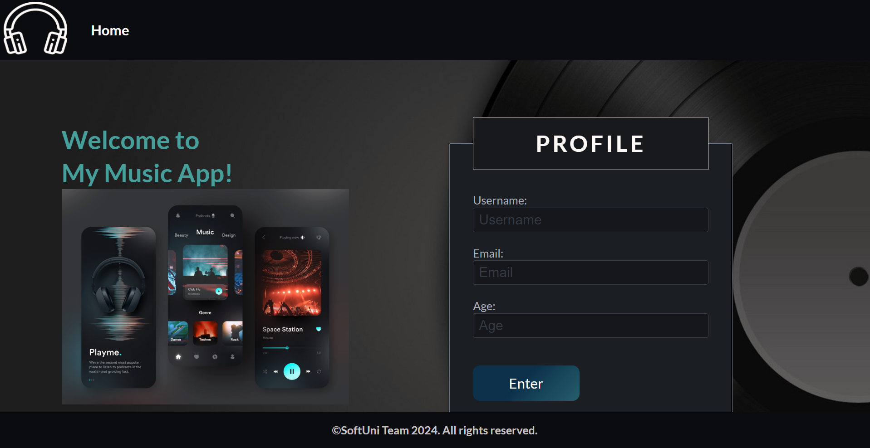

The "Home with Profile" page displays all albums created by the user. If no albums exist, only a paragraph is visible: "No Albums in Catalog!"
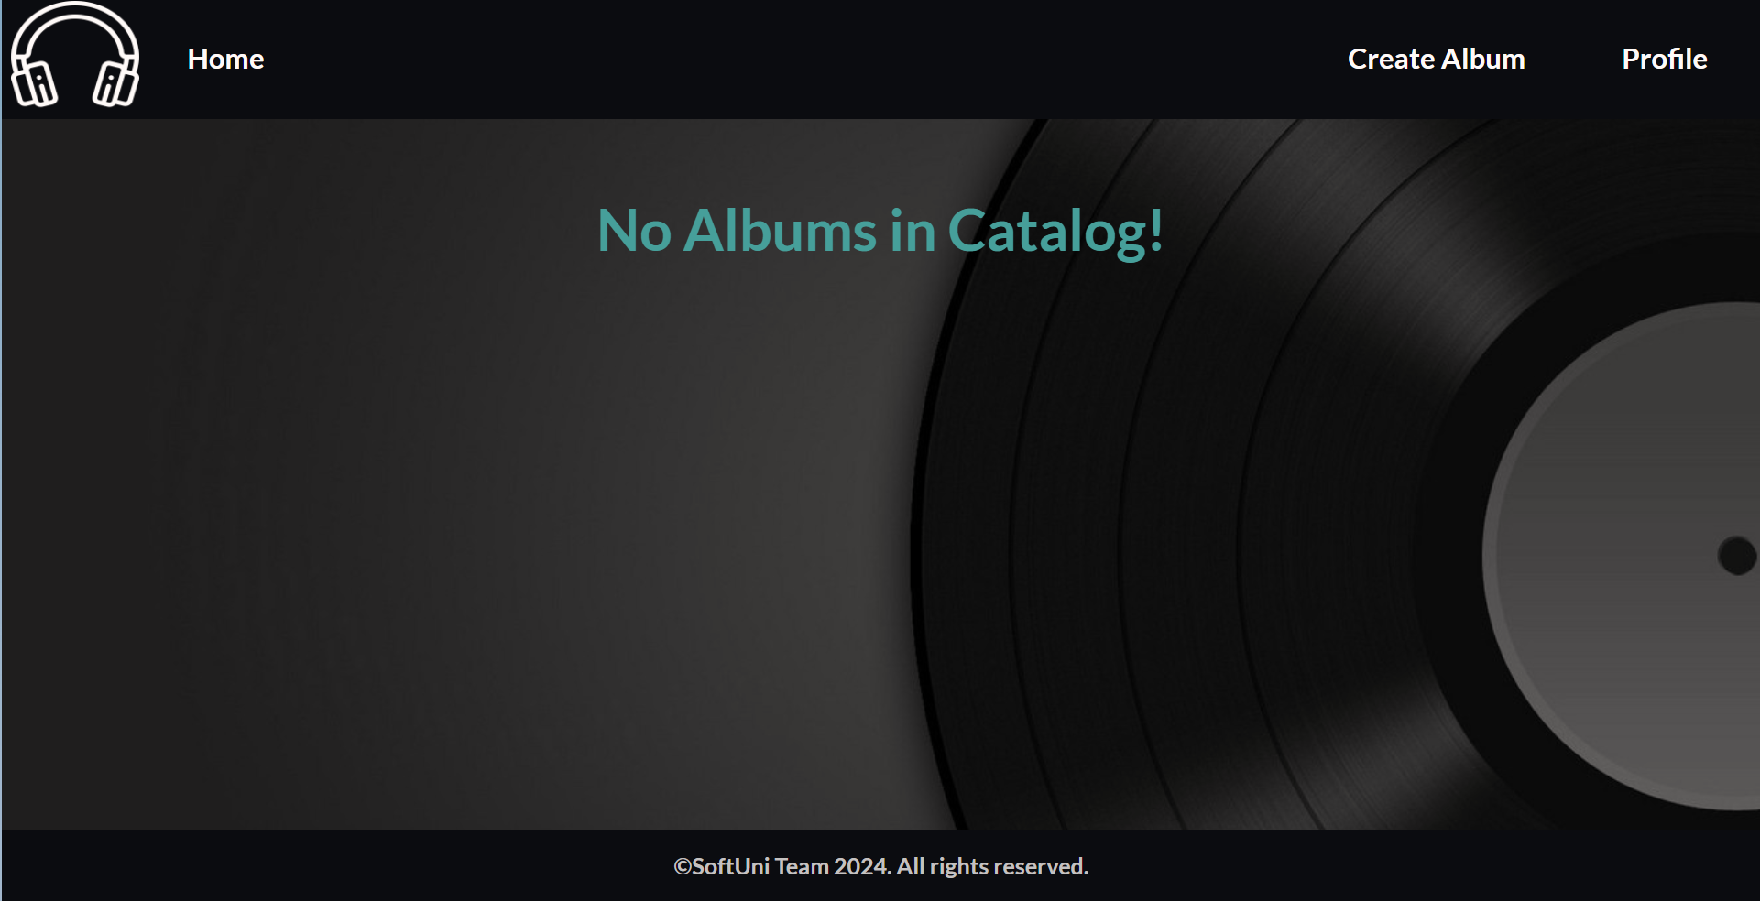
If a profile and album/s exist, the page should include the following components:
- A navigation bar, as displayed below.
- A headline titled "All Albums"
- A card for each album, featuring the album's image, name, artist, genre, and price (formatted to the second decimal place). Each card-box should have a "Details" button, leading to the details page for the selected album.
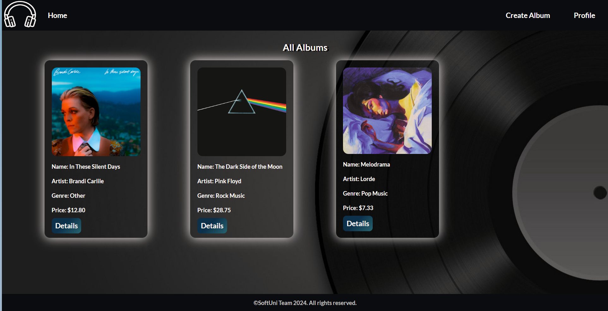

Add Album Page
Template file: "album-add.html"
This page displays an album creation form containing:
- An "Album Name:"
  - There must be a placeholder "Album Name".
- An "Artist:"
  - There must be a placeholder "Artist".
- A "Genre:"
  - The user is required to select one option from the provided choices in the drop-down list.
- A "Description:"
  - There must be a placeholder "Description".
- An "Image URL:"
  - There must be a placeholder "Image URL".
- A "Price:"
  - There must be a placeholder "Price".
- A button "Add New Album"
  - Upon clicking, successful album creation redirects to the home page, displaying a template for a home page with the user's profile.
  - In case of any errors, the form will present the relevant validation messages.
- Associate the new album with the user profile you already have in the database.
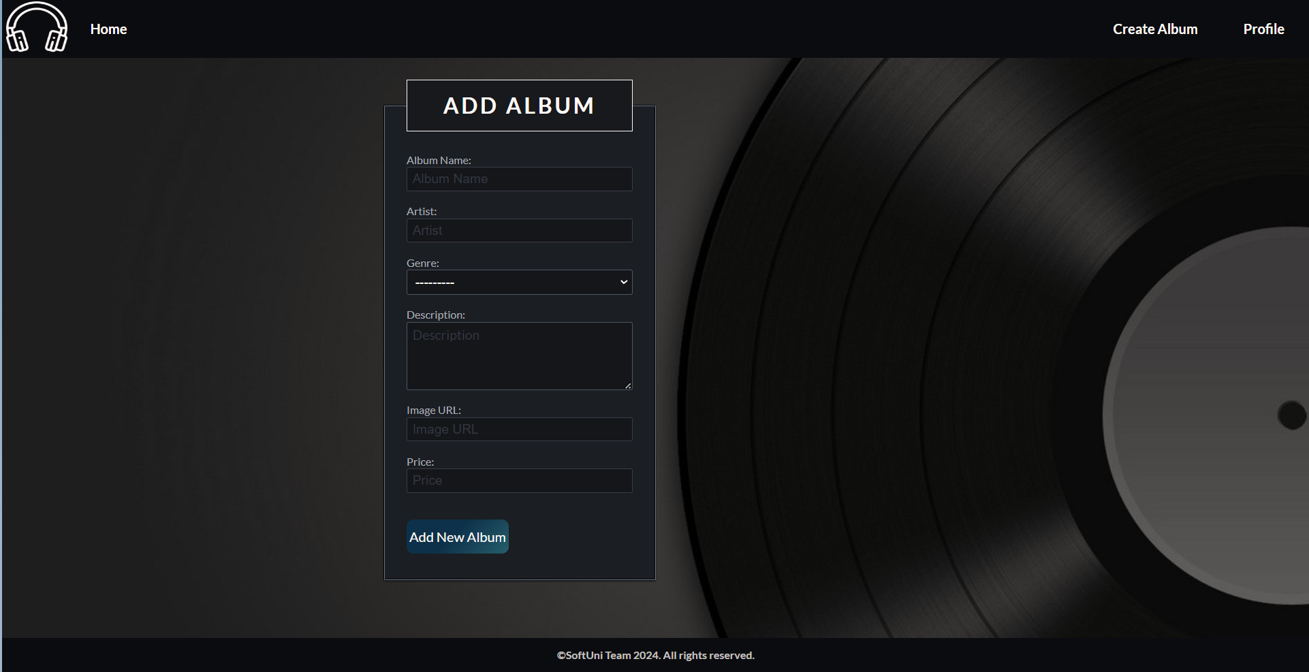

Album Details Page
Template file: "album-details.html"
This page showcases the details of the selected album, including the following information:
- The album's image
- The album's name
- The artist's name
- The genre of the album
- The price of the album, formatted to the second decimal place
- The page will include the description if provided; otherwise, this line will be omitted
- An "Edit" button that leads to the Edit album page
- A "Delete" button that leads to the Delete album page

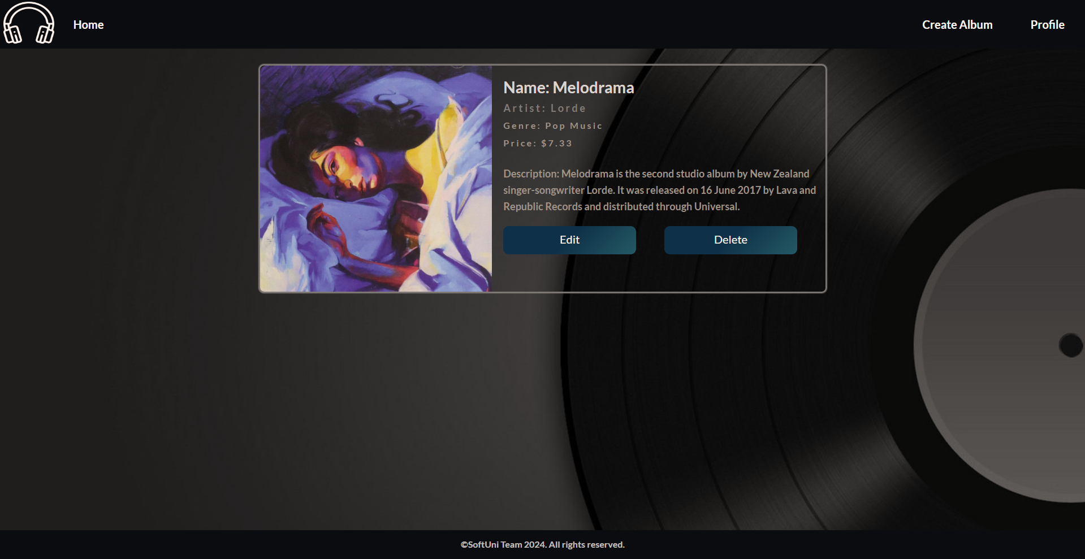

Edit Album Page
Template file: "album-edit.html"
On the page, the form should be pre-filled with the data of the selected album for editing.
Note that the price should have no limit on the number of decimal places both when displayed and during editing.
When the "Edit Album" button is clicked:
- If the album is successfully edited, redirection to the home page occurs, displaying a template for a home page with the user's profile.
- Otherwise, the form will present relevant validation errors.
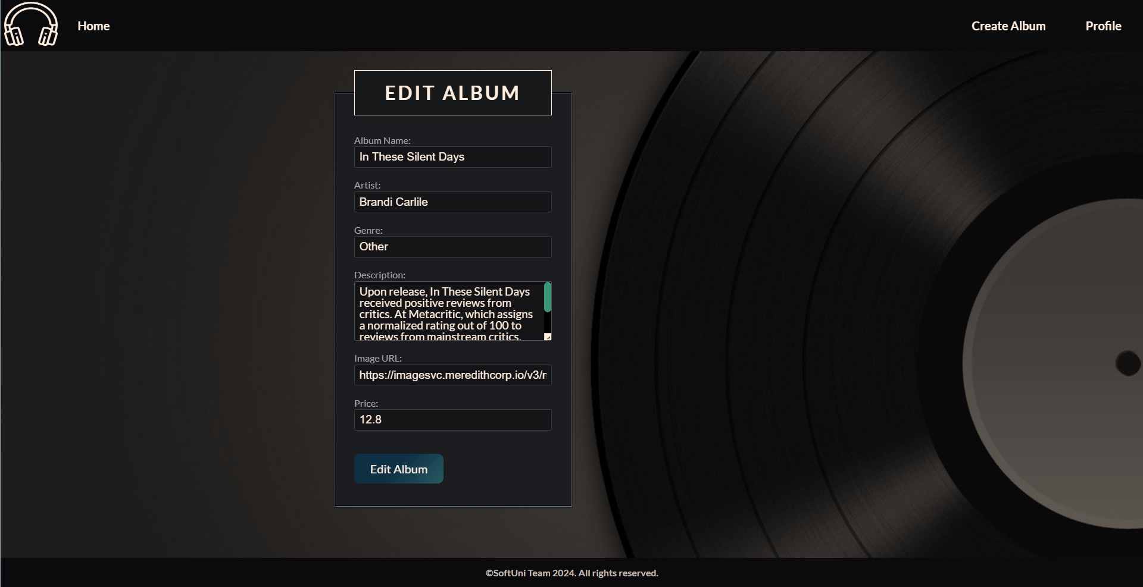

Delete Album Page
Template file: "album-delete.html"
On this page, the form should be populated with the album's data, and the fields should be read-only.
Clicking the "Delete" button will remove the album from the database, and you will be redirected to the home page, displaying a template for a home page with the user's profile.
The deleted album should no longer be visible in the app.

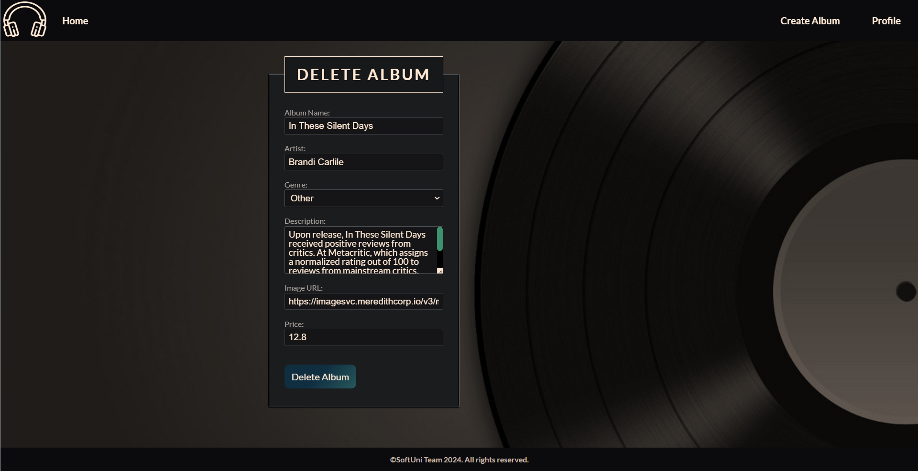

Profile Details Page
Template file: "profile-details.html"
This page displays the user's information, including:
- The default profile image (as a source link in the HTML code)
- The username
- The email
- The age (if provided); otherwise, this line is omitted
- The total number of albums that the user currently has. Display 0 (zero) if the user has no albums
- A "Delete" button that leads to the Delete profile page
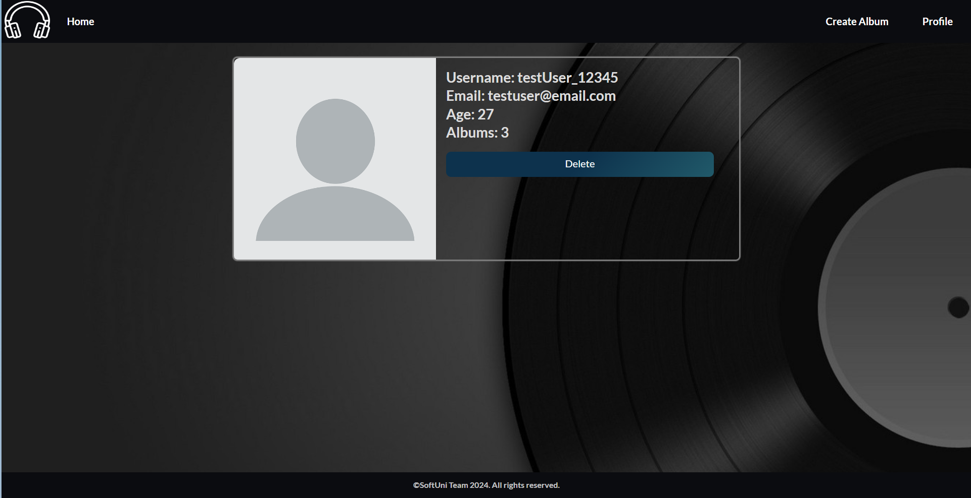

Delete Profile Page
Template file: "profile-delete.html"
Deleting a profile should delete the profile info and all associated albums. After deletion, the user should be redirected to the home page with no profile.
